Kia Sorento Review: Price, Specifications, Features & Full Details


Introduction: A Global Icon, Reimagined for India
Kia has built a reputation for bringing genuinely global products to India rather than watered-down versions built just for the price-conscious buyer, and the new Kia Sorento is easily one of the strongest examples of that philosophy yet. Marketed as a "Global Icon, Reimagined for India," the Sorento arrives as a full-size three-row SUV that brings together sophisticated design, hybrid and diesel powertrain choices, confident All-Wheel Drive capability, an advanced ADAS Level 2+ suite, and the kind of AI-powered connected technology that most buyers would associate with cars costing significantly more.
For readers of BikeCarHub who have been waiting for a proper premium three-row SUV from Kia in India, the Sorento is worth serious consideration. In this article, we're breaking down everything Kia has revealed about the new Sorento — its design language, cabin experience, engine and transmission choices, safety and ADAS technology, connected car features, variants, colours, and where it's priced in the Indian market. Whether you're comparing full-size SUVs for a large family or simply curious about what Kia's flagship SUV brings to the table, this guide aims to give you the complete picture.
The Kia Sorento is priced from ₹27,99,000 to ₹38,49,000 (ex-showroom), positioning it as a premium three-row SUV that competes with some of the most feature-rich and capable options in its segment. Let's get into what makes this SUV such a compelling proposition.

Exterior Design: Iconic Presence Needs No Introduction
Kia's design philosophy for the new Sorento centres on a presence that feels effortless rather than try-hard. From its bold stance and signature lighting to its sculpted silhouette, every exterior detail has clearly been considered, and nothing about the design feels overstated. The face is dominated by Kia's Digital Tiger Face design language, paired with Crystal Cube LED Projection headlamps that feature auto light control, ensuring both a striking visual identity and genuinely useful illumination after dark.
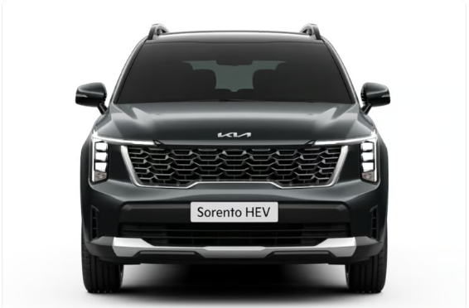
The signature lighting continues at the rear with Starmap LED tail lamps, a design touch that instantly sets the Sorento apart from other SUVs on Indian roads. An integrated rear spoiler with a hidden wiper adds a clean, uncluttered look to the tailgate, while high-glossy bridge-type roof rails and up to 19-inch (48.2 cm) premium crystal-cut alloy wheels round off a stance that looks planted and substantial without feeling bulky.
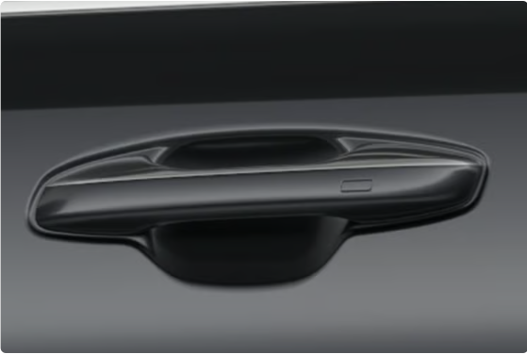
Thoughtful ergonomic touches are woven throughout the exterior too — grab handles with touch sensors and pocket lighting make entering the cabin feel a little more special, while the dual-pane panoramic sunroof (standard from the HTK trim upward) hints at the premium cabin experience waiting inside.
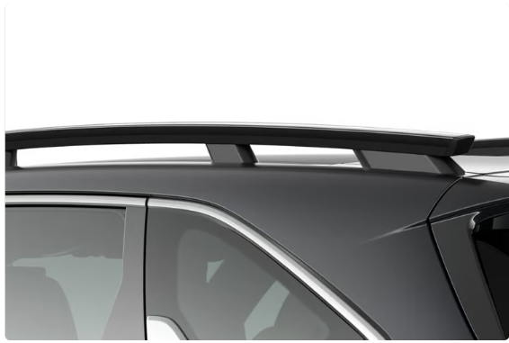

Interior & Cabin Comfort: Indulgent Comfort Makes the Long Way Tempting
Step inside the Sorento, and Kia's tagline for the cabin — "take your time" — genuinely makes sense. The cabin brings together generous space, premium finishes, and technology that feels right at home, whether you're on a short city commute or a long highway drive. Every detail, from the comfort of the 12-way Ergo Motion driver's seat to the 64-colour ambient lighting that runs across the dashboard, has been designed to make settling in effortless.
Depending on variant, buyers can choose between a Smoky Black & Grey two-tone interior with leatherette seats (HTE, HTE(O), HTK, HTK(A) and HTK(A) Black Line), or a more premium Black & Olive Brown two-tone interior with embossed leatherette seats on the range-topping HTX and HTX(A) AWD variants. Front Row Relaxation Comfort Seats, available on the top trims, add an extra layer of indulgence for those long highway journeys the Sorento is clearly built for.
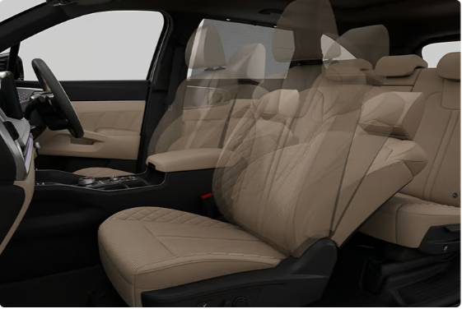

Seating Flexibility: 6 or 7 Occupants, Your Choice
The Sorento is offered in both 6-seater (with second-row captain seats) and 7-seater (with a conventional bench) configurations, depending on variant and trim. The second row gets 60:40 split seats with slide, recline, remote folding, and walk-in function, while the third row features 50:50 split seats with folding — genuinely useful for families who need to reconfigure the cabin for either passengers or cargo on any given day.

Technology & Infotainment: Adaptive Intelligence That Makes Itself Useful
This is an area where the Sorento genuinely punches above its segment. At the centre of the experience is the Kia AI Assistant, a real-time Generative AI feature (intelligence powered by Perplexity, with voice AI powered by SoundHound AI, and CCNC acceleration by NVIDIA) that makes interacting with the car feel far more natural than a typical voice command system — helping occupants find information, get answers, and make the most of their drive through natural conversation.
The Sorento is built around a Panoramic Curved Display Panel on higher trims, combining a 31.24 cm (12.3-inch) HD touchscreen navigation cockpit with a matching 31.24 cm (12.3-inch) HD digital instrument cluster, and a Head-up Display windshield projection on the range-topping HTX(A) AWD variant. Kia Connect 2.0 brings over 85 connected car features to the table, covering everything from remote engine start to vehicle status checks, all accessible via the Kia Connect app — and it comes with a 3-year free subscription.
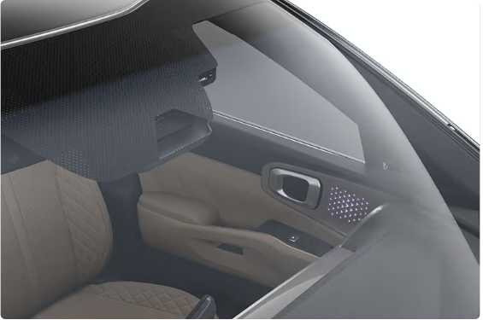

Staying Current with OTA Updates
Rather than requiring a dealership visit for every software improvement, the Sorento supports Over-the-Air (OTA) software updates for up to 30 controllers, meaning the car can genuinely evolve over time as Kia rolls out new features and refinements — a rare capability at this price point in India.

Audio, Charging & Connectivity
Music lovers on the higher trims are treated to a Bose Premium Sound System with 12 speakers, delivering a genuinely immersive in-cabin audio experience. Practical touches include a smartphone wireless charger, C-Type USB charging ports across all rows (two per row), an Infotainment-Temperature Control Swap Switch for quick access to climate controls, and — uniquely for this segment — a 220V power outlet in the cabin, letting occupants plug in laptops and other household electronics directly.
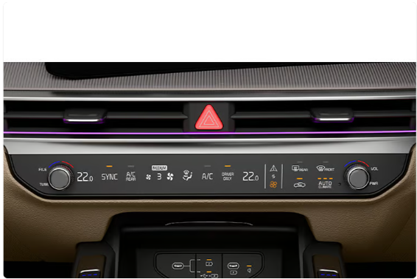

Digital Key 2.0 & Smart Convenience
Kia's Digital Key 2.0 lets owners lock, unlock, and even start the Sorento using just their smartphone, while features like Remote Seat Ventilation Control, Remote Vehicle Immobilization, and Find My Car with Surround View Monitor (SVM) round off a genuinely comprehensive connected ownership experience managed entirely through the Kia Connect app.
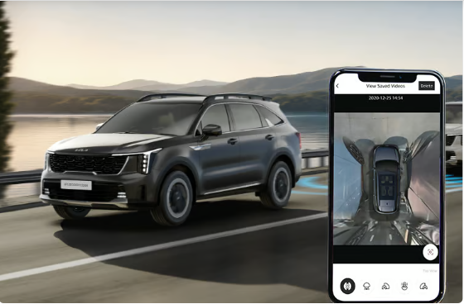

Engine, Performance & Transmission Options
The Sorento offers two distinct expressions of performance, giving buyers real choice depending on how they intend to use the SUV. There's more than one way to enjoy the drive here, and sporty paddle shifters on both powertrains let drivers take a more active role whenever they choose to.
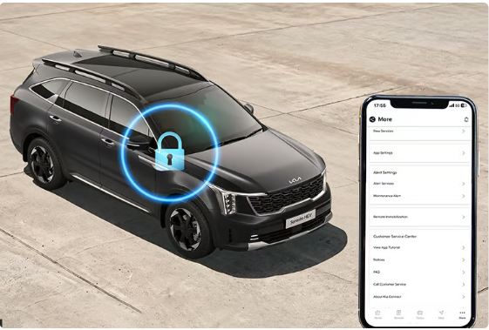

Smartstream D2.2 Diesel with 8DCT
The diesel option is a 2.2-litre Smartstream D2.2 engine producing a healthy 142 kW of power at 3,800 rpm along with 442 Nm of torque available between 1,750 and 2,750 rpm, paired exclusively with an 8-speed dual-clutch transmission (8DCT). This is the engine to pick for buyers who value strong low-end pulling power, particularly useful when the Sorento is loaded with passengers and luggage or when opting for the AWD system on higher trims.

Smartstream 1.6 Turbo GDI Hybrid with 6AT
The petrol hybrid option pairs a 1.6-litre turbocharged GDI engine with an electric motor, producing a combined 132.4 kW from the engine and 47.7 kW from the motor (peak engine output at 5,500 rpm), along with 265 Nm of torque from the engine and 264 Nm from the motor, delivered through a smooth 6-speed automatic transmission. Kia says this 1.6T HEV powertrain has been engineered specifically for India, balancing efficiency with confident performance while delivering best-in-class NVH (noise, vibration, and harshness) refinement.
A particularly clever feature on the hybrid variants is first-in-category Vehicle-to-Load (V2L) technology, which lets the Sorento's battery power external devices — think camping equipment, power tools, or emergency household appliances during a power cut — through the cabin's 220V outlet, adding a layer of genuine everyday versatility beyond just being a mode of transport.
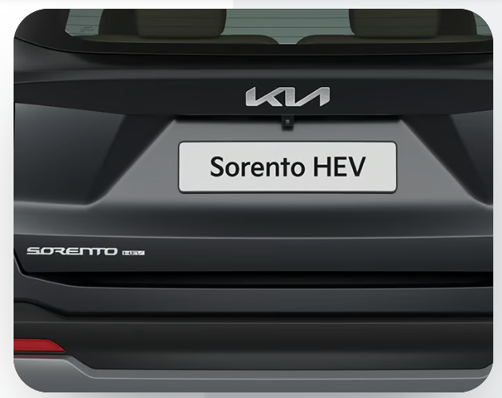

Drive Modes & AWD
Drive modes across the range include Eco, Sport, Smart, and Normal (Normal mode is exclusive to the diesel), letting drivers tailor throttle response and overall character to their mood or road conditions. The range-topping HTX and HTX(A) AWD variants add genuine All-Wheel Drive capability with selectable Terrain Modes for Snow, Mud, and Sand, giving the Sorento real versatility well beyond city and highway driving.
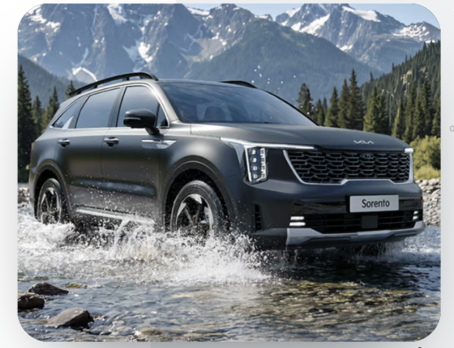

Dial-Type Shift-By-Wire Selector
Rather than a conventional gear lever, the Sorento's hybrid and diesel AT variants use a dial-type shift-by-wire selector, freeing up centre console space for additional storage while adding a genuinely premium, tactile feel to everyday gear selection.

Safety: Advanced Safety Thinks Beyond the Obvious
Kia has built the Sorento to give occupants confidence beyond what they can visually perceive themselves — up to 10 airbags provide comprehensive protection on the top trims, while the 360-degree camera system gives a clearer view of the SUV's surroundings, helping drivers stay aware in moments that demand a little extra attention.

Robust 26 Hi-Safety Package — Standard Across All Variants
Every single Sorento variant, right from the entry-level trim, comes with what Kia calls the Robust 26 Hi-Safety Package — a genuinely comprehensive list of 26 safety features as standard, rather than reserved for higher trims. This includes:
- Front Dual Airbags, Front Seat Side Airbags, Side Curtain Airbags, and Driver Knee Airbag
- ABS (Anti-lock Braking System) and BAS (Brake Assist System)
- ESC (Electronic Stability Control) and VSM (Vehicle Stability Management)
- HAC (Hill-start Assist Control) and DBC (Downhill Brake Control)
- ESS (Emergency Stop Signal) and MCB (Multi Collision Brake)
- Highline Tyre Pressure Monitoring System and Rollover Sensor
- Rear Occupant Alert, ISOFIX child seat mounts, and Front Passenger Airbag On/Off switch
- Rear View Camera with Dynamic Guidelines and Auto Light Control
- Speed Sensing Auto Door Locks and Impact Sensing Auto Door Unlock
- Front & Rear All-Seat 3-Point Seatbelts with Reminder, and Child Lock
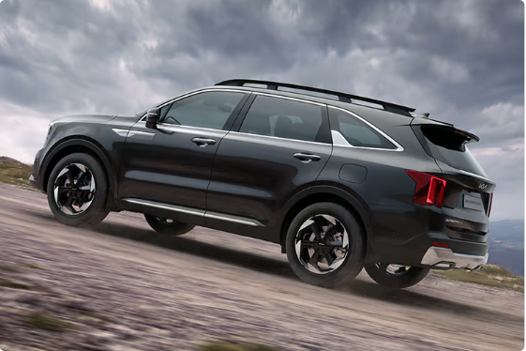

ADAS Level 2 and Level 2+: Intuitive Technology That Anticipates the Unexpected
The Sorento's Advanced Driver Assistance System (ADAS) technology is offered in two tiers depending on variant. The HTK(A) trim gets ADAS Level 2 with 21 autonomous features, including Forward Collision Warning and Avoidance Assist (covering cars, pedestrians, cyclists, direct oncoming, and junction turning scenarios), Lane Departure Warning, Lane Keeping and Lane Following Assist, High Beam Assist, Driver Attention Warning, Blind Spot Collision Warning and Avoidance Assist, Rear Cross Traffic Collision Warning and Avoidance Assist, Safe Exit Warning, and Smart Cruise Control with Stop & Go.
The range-topping HTX(A) AWD variant steps this up further with ADAS Level 2+ featuring 29 autonomous features, adding Junction Crossing and Lane Change collision-avoidance scenarios, Front Collision-Avoidance Assist with Evasive Steering, Highway Driving Assist (HDA), Remote Smart Parking Assist, and Navigation-Based Smart Cruise Control for both Zones (NSCC-Z) and Curves (NSCC-C) — technology that brings the Sorento genuinely close to a semi-autonomous highway driving experience while keeping the driver firmly in control and responsible for safe driving at all times.
Kia is careful to note — and BikeCarHub echoes this — that ADAS features are designed to assist the driver, not replace them, and drivers should remain vigilant and attentive at all times regardless of how capable the assistance systems are.
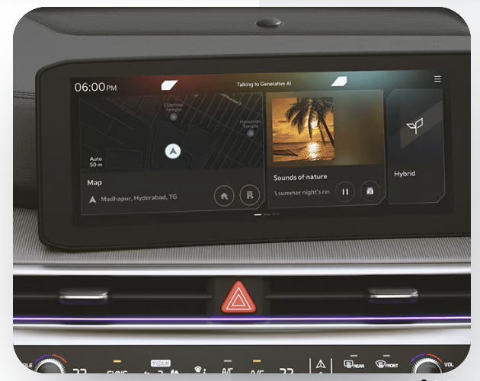

Variants, Trims & Feature Packages
The Kia Sorento line-up is structured around three core trims — HTE, HTK, and HTX — with several optional packages layered on top, giving buyers a genuinely wide spread of configurations to choose from.
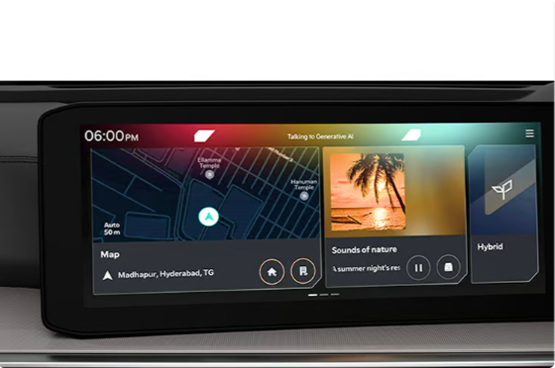

HTE & HTE(O) — The Entry Point
The base HTE trim already comes generously equipped, featuring Crystal Cube MFR LED headlamps with auto light control, Star Map LED DRLs with integrated turn signals, an 18-inch (46.20 cm) sporty crystal-cut alloy wheel set, a 31.24 cm (12.3-inch) HD touchscreen, a 10.5 cm (4.2-inch) colour TFT MID, dual-zone automatic climate control, a smart key with push-button start, wireless smartphone charger, cruise control with manual speed limit assist, and the full Robust 26 Hi-Safety Package including 7 airbags. The HTE(O) adds a Convenience Package on top of this base specification.
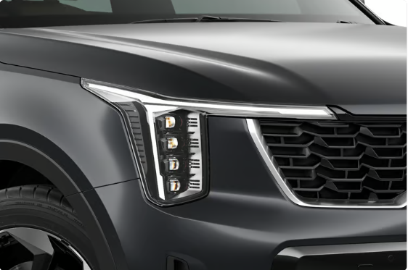


HTK & HTK(A) — The Sweet Spot
Moving up to HTK adds Crystal Cube LED Projection headlamps, Star Map LED tail lamps, LED fog lamps, 19-inch (48.2 cm) premium crystal-cut alloy wheels, a dual-pane panoramic sunroof, the Panoramic Curved Display Panel (12.3-inch touchscreen and 12.3-inch digital cluster combined), Kia Connect 2.0 with OTA updates, a Bose 12-speaker sound system, 360-degree camera, Blind View Monitor, side parking sensors, and 64-colour ambient mood lighting. The HTK(A) variant adds the full ADAS Level 2 package with 21 autonomous features, while an HTK(A) Black Line option applies a blacked-out styling treatment to exterior elements like the Kia and Sorento emblems, alloy wheels, fender garnish, and beltline.
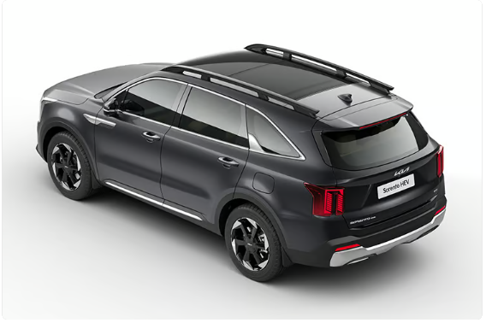

HTX & HTX(A) AWD — The Flagship
At the top of the range, HTX and HTX(A) AWD variants bring in the premium Black & Olive Brown two-tone interior, Digital Key 2.0, Advanced Digital IRVM, Head-up Display windshield projection, Remote Smart Parking Assist, built-in navigation, and the Kia AI Assistant with real-time Generative AI and voice command. Comfort is elevated further with up to 10 airbags, driver memory seats linked to mirrors and HUD, Front Row Relaxation Comfort Seats, ventilated seats front and rear, a 220V power outlet, front and rear dashcams, and genuine AWD with selectable Terrain Modes. The flagship HTX(A) AWD also unlocks the full ADAS Level 2+ suite with 29 autonomous features. Black Line styling options are available across the HTX range as well.
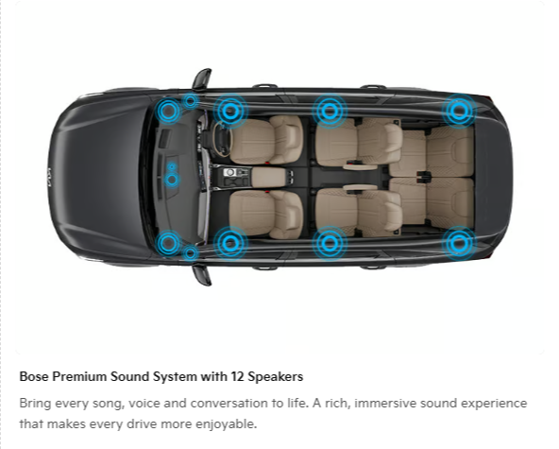

Colour Options
Buyers can choose the Kia Sorento in eight distinctive shades:
- Dark Gun Metal (Matte) – exclusive from the HTX trim onward
- Aurora Black Pearl
- Glacier White Pearl
- Magma Red
- Ivory Silver (Glossy)
- Gravity Gray
- Imperial Blue
- Pewter Olive

Kia Sorento Price in India
The Kia Sorento is priced from ₹27,99,000 to ₹38,49,000 (ex-showroom) across its variant lineup, spanning the well-equipped entry-level HTE trim all the way up to the fully loaded HTX(A) AWD flagship with ADAS Level 2+. This positions the Sorento as a premium three-row SUV option, competing on genuine feature depth, powertrain choice, and safety technology rather than on outright value pricing.
As always, the team at BikeCarHub recommends confirming the final on-road price with your nearest Kia dealership, since RTO registration, insurance, and state-specific taxes can add a meaningful amount over the ex-showroom figure. Given the wide spread of variants and two very different powertrain characters on offer, it's worth test-driving both the diesel and hybrid before deciding which suits your driving needs best.

Warranty & After-Sales Support
Kia backs the Sorento with a reassuring ownership package. The vehicle comes with a standard 3-year unlimited-kilometre warranty, extendable up to 5 years (a 3+2 structure), giving buyers real peace of mind over a long ownership period. The high-voltage battery on hybrid variants is separately covered for 8 years or 1,60,000 km. Ownership is further supported by 24x7 Nationwide Roadside Assistance, the My Convenience Plus programme, the Kia Care Network, access to Kia Genuine Spare Parts, Smart Services, and a 360-degree Digital Experience for managing service and support needs.
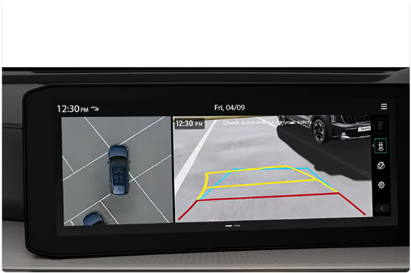

Kia Sorento vs Rivals: How Does It Compare?
The Sorento enters India's full-size three-row SUV segment where feature-loaded, safety-focused options are becoming the norm rather than the exception. While direct rivals vary by body style, powertrain, and pricing, buyers cross-shopping the Sorento will typically also look at other premium three-row SUVs available in the Indian market. Below is a general comparison of the kind of aspects buyers typically weigh when comparing the Sorento against rival large SUVs — always verify the latest specifications and pricing for competitor models directly with their respective manufacturers, since these figures change frequently.
Parameter | Kia Sorento | Typical Rival Full-Size SUVs
Powertrain Choice | 2.2L Diesel (8DCT) or 1.6T Petrol Hybrid (6AT) | Usually a single diesel or petrol option
Combined Hybrid Power | 132.4 kW (Engine) + 47.7 kW (Motor) | Varies; hybrid options less common in segment
Drivetrain | 2WD or AWD with Terrain Modes (top trim) | Often FWD-only or optional AWD on limited trims
ADAS | Level 2 (21 features) / Level 2+ (29 features) | Ranges from none to Level 2, depending on brand
Standard Safety | 26-feature Hi-Safety Package on all variants | Varies significantly by trim and brand
Seating | 6-seater (captain seats) or 7-seater | Usually 7-seater only
Connected Tech | Kia AI Assistant, Kia Connect 2.0, OTA updates | Varies; AI assistants are rare in this segment
Price Range | ₹27,99,000 – ₹38,49,000 (ex-showroom) | Broadly overlapping premium price bands
As the table suggests, the Sorento's strongest differentiators are its genuine choice between diesel and hybrid powertrains, its class-leading ADAS suite on the top trim, and connected technology like the Kia AI Assistant that few rivals currently offer. Buyers focused purely on outright value or brand familiarity may still want to cross-shop other large SUVs, but those who value technology depth and powertrain flexibility will find the Sorento's proposition hard to match.

Kia Sorento: Full Specifications

Engine and Transmission
Specification | Smartstream D2.2 Diesel | Smartstream 1.6 Turbo GDI Hybrid
Fuel System | MPi | T-GDi
Displacement | 2,151 cc | 1,598 cc
Max Power | 142 kW @ 3,800 rpm | 132.4 kW (Engine) & 47.7 kW (Motor) @ 5,500 rpm
Max Torque | 442 Nm @ 1,750–2,750 rpm | 265 Nm (Engine) & 264 Nm (Motor) @ 1,500–4,500 rpm
Transmission | 8-Speed DCT | 6-Speed AT
Drive System | 2WD / AWD (select variants) | 2WD / AWD (select variants)

Suspension, Brakes & Tyres
Specification | Detail
Front Suspension | McPherson Strut & Stabilizer
Rear Suspension | Independent Multi-link
Brakes | Disc – All Wheels
Tyre Size (Vehicle) | 235/55 R19 (HTK–HTX(A)) / 235/60 R18 (HTE & HTE(O))
Spare Tyre | 135/80 D18 (Steel)

Dimensions, Fuel & Practicality
Specification | Detail
Overall Length | 4,815 mm
Overall Width | 1,900 mm
Overall Height | 1,785 mm (with bridge-type roof rack)
Wheelbase | 2,815 mm
Fuel Tank Capacity | 67 litres
Seating Capacity | 6 or 7 persons
Boot Space | 813 litres (with 2nd row) / 179 litres (with 3rd row)

Complete Feature Highlights

Exterior Highlights
- Crystal Cube LED Projection Headlamps with Auto Light Control
- Star Map LED DRLs with Integrated Turn Signals & Star Map LED Tail Lamps
- Kia Digital Tiger Face front design
- Dual-Pane Panoramic Sunroof
- Integrated Rear Spoiler with Hidden Wiper
- High Glossy Bridge Type Roof Rails
- Up to 19-inch (48.2 cm) Premium Crystal Cut Alloy Wheels
- Grab Handles with Touch Sensor & Pocket Lighting

Interior & Comfort
- 12-way Ergo Motion power driver's seat with lumbar adjust (top trims)
- 8-way power passenger seat (higher trims)
- Front Row Relaxation Comfort Seats (HTX AWD onward)
- Comfort Front & Rear Ventilated Seats with 3-step cooling
- 64 Colour Ambient Mood Lighting
- Dual Zone Automatic Temperature Control with Rear AC Vents (2nd & 3rd row)
- 60:40 split 2nd row with slide, recline, remote folding & walk-in; 50:50 split 3rd row
- 220V Power Outlet with V2L technology (Hybrid)
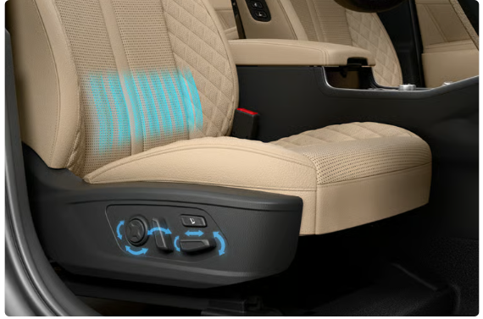
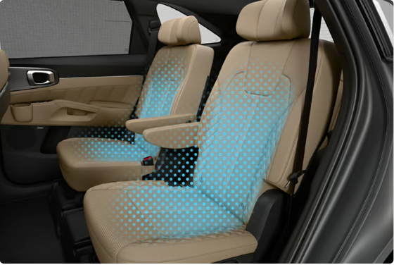

Technology & Connectivity
- 31.24 cm (12.3-inch) HD Touchscreen Navigation Cockpit
- 31.24 cm (12.3-inch) HD Digital Instrument Cluster with Head-up Display (top trim)
- Kia AI Assistant with Real-Time Generative AI (HTX AWD onward)
- Kia Connect 2.0 with 85+ connected features & OTA updates for 30 controllers
- Bose Premium Sound System with 12 Speakers
- Digital Key 2.0 and Advanced Digital IRVM
- Smartphone Wireless Charger & C-Type USB ports (all rows)


Safety & ADAS
- Up to 10 Airbags (Front, Side, Curtain, Rear Side, Center & Driver Knee)
- Robust 26 Hi-Safety Package standard across all variants
- 360 Degree Camera with Blind View Monitor in Cluster
- ADAS Level 2 (21 features) on HTK(A); ADAS Level 2+ (29 features) on HTX(A) AWD
- Remote Smart Parking Assist
- 12 Parking Sensors with 5 Radars
- Highline Tyre Pressure Monitoring System
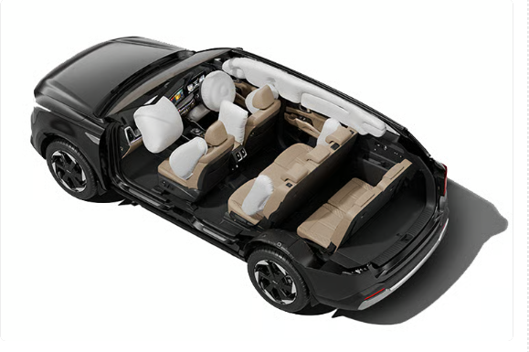

Pros and Cons

What Works in the Sorento's Favour
- Genuine choice between a punchy diesel and an India-tuned hybrid powertrain
- Class-leading ADAS Level 2+ suite with 29 autonomous features on the top trim
- Kia AI Assistant and Kia Connect 2.0 bring genuinely advanced connected technology
- Comprehensive 26-feature safety package standard from the base variant
- Flexible 6 or 7-seater configurations with a spacious, premium cabin
- Strong warranty coverage, extendable up to 5 years, plus 8-year hybrid battery cover

Where Buyers Should Do Their Homework
- Starting price of ₹27,99,000 places it firmly in the premium SUV bracket
- AWD and the full ADAS Level 2+ suite are reserved for the top HTX(A) AWD variant
- Buyers should compare on-road pricing and real-world mileage of diesel vs hybrid before deciding
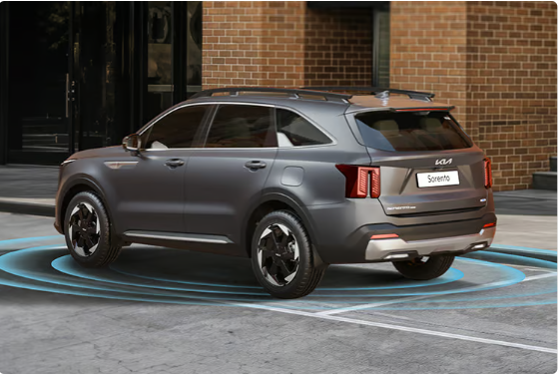

Final Verdict: Is the Kia Sorento Worth Considering?
The Kia Sorento makes a genuinely strong case for itself as one of the most technologically advanced three-row SUVs available in India today. Its dual powertrain strategy — a strong, torquey diesel alongside an India-tuned hybrid with clever V2L capability — means it can suit very different kinds of buyers under one nameplate, while its ADAS Level 2+ suite and Kia AI Assistant push the segment's technology bar higher than most rivals currently manage. Add to that a genuinely premium cabin, flexible 6/7-seater configurations, and a comprehensive standard safety package, and the Sorento looks like a thoughtfully complete package rather than a car chasing a single headline feature.
At a starting price of ₹27,99,000 going up to ₹38,49,000 (ex-showroom), the Sorento is clearly positioned as a premium purchase — and for buyers who value technology depth, powertrain choice, and comprehensive safety over outright value pricing, that positioning makes sense. As always, the team at BikeCarHub recommends a test drive across both the diesel and hybrid variants before finalising your decision, so you can experience the difference in character firsthand. We'll continue to update this article as more real-world reviews, ownership feedback, and pricing details on the Kia Sorento become available — so keep checking back on BikeCarHub for the latest.

Frequently Asked Questions (FAQs)

1. What is the price of the Kia Sorento in India?
The Kia Sorento is priced from ₹27,99,000 to ₹38,49,000 (ex-showroom) depending on the variant, powertrain, and drivetrain chosen. It's best to confirm the latest on-road price with your local Kia dealership.

2. What engine options does the Kia Sorento offer?
The Sorento is available with a 2.2-litre Smartstream D2.2 diesel engine producing 142 kW and 442 Nm of torque paired with an 8-speed DCT, or a 1.6-litre Smartstream Turbo GDI Hybrid producing a combined 132.4 kW (engine) and 47.7 kW (motor) paired with a 6-speed automatic transmission.

3. Is the Kia Sorento available with All-Wheel Drive?
Yes, AWD is available on the range-topping HTX and HTX(A) variants, complete with selectable Terrain Modes for Snow, Mud, and Sand conditions.

4. Does the Kia Sorento offer ADAS (Advanced Driver Assistance Systems)?
Yes. The HTK(A) trim offers ADAS Level 2 with 21 autonomous features, while the flagship HTX(A) AWD variant offers ADAS Level 2+ with 29 autonomous features, including Highway Driving Assist and Navigation-Based Smart Cruise Control.

5. How many seats does the Kia Sorento offer?
The Sorento is available in both 6-seater (with second-row captain seats) and 7-seater (conventional bench) configurations, depending on the variant chosen.

6. What is the boot space of the Kia Sorento?
The Sorento offers 813 litres of boot space with the third row in use (i.e., loading behind the second row), and 179 litres of space with all three rows in use (behind the third row).

7. What safety features come standard on the Kia Sorento?
Every Sorento variant comes with the Robust 26 Hi-Safety Package as standard, which includes front, side, and curtain airbags, ESC, VSM, Hill-start Assist Control, a Highline Tyre Pressure Monitoring System, ISOFIX mounts, and 7 airbags at minimum, among 26 total safety features.

8. What is Kia AI Assistant, and which variants get it?
Kia AI Assistant is a real-time Generative AI voice assistant (intelligence by Perplexity, voice AI by SoundHound AI) that lets occupants interact naturally with the car for information, navigation, and more. It's available from the HTX AWD trim upward.

9. What is the warranty on the Kia Sorento?
The Sorento comes with a standard 3-year unlimited-kilometre warranty, extendable up to 5 years (3+2 structure). The high-voltage battery on hybrid variants is separately covered for 8 years or 1,60,000 km, along with 24x7 nationwide roadside assistance.

10. What colours is the Kia Sorento available in?
The Sorento is offered in eight shades: Dark Gun Metal (Matte, exclusive to HTX trims onward), Aurora Black Pearl, Glacier White Pearl, Magma Red, Ivory Silver (Glossy), Gravity Gray, Imperial Blue, and Pewter Olive.

SEO Metadata

Title Tag
Kia Sorento Price, Specs & Features in India 2026

Meta Description
Explore the Kia Sorento's price, specs, ADAS features & mileage. Read BikeCarHub's detailed review of this premium 3-row SUV before you buy.

Important SEO Keywords
- Kia Sorento price in India
- Kia Sorento review
- Kia Sorento specifications
- Kia Sorento hybrid vs diesel
- Kia Sorento ADAS features
- Kia Sorento AWD
- Kia Sorento mileage
- Kia Sorento vs rivals
- Kia AI Assistant Sorento
- Kia Sorento price 2026

